|  |
| --- |
| ECONOMICAL MOBIWISE INSIGHT SYSTEM (EMWIS) |
| Project Proposal |

## Project Title

**Economical MobiWise Insight System (EMWIS)**  
*A Smart and Economical Mobile Price Comparison and Purchasing Platform*

## Project Overview

The Economical MobiWise Insight System is a full-fledged web-based platform designed to revolutionize the way users discover, compare, and purchase mobile phones across online. It bridges the gap between price-conscious customers and dynamic market pricing by integrating real-time data, admin-curated offers, and intelligent UI/UX tailored for decision-making.

## Objectives of the Project

* To provide a comprehensive comparison of mobile phone prices across multiple platforms.
* To allow direct purchasing via a unified cart and checkout system.
* To notify users of price drops and discounts.
* To empower admins with role-based tools for data and order management.
* To address the gaps and inefficiencies in current mobile price tracking platforms.

## Problem Statement / Existing System Drawbacks

Despite the rapid growth of e-commerce and price comparison platforms, **current systems** fall short in several critical areas:

**A. Existing System Drawbacks:**

* Inability to track price history or receive alerts.
* **Example:** *Flipkart.com* – Although product prices fluctuate frequently, **Flipkart does not notify users** when prices fall for previously viewed or wishlisted products.

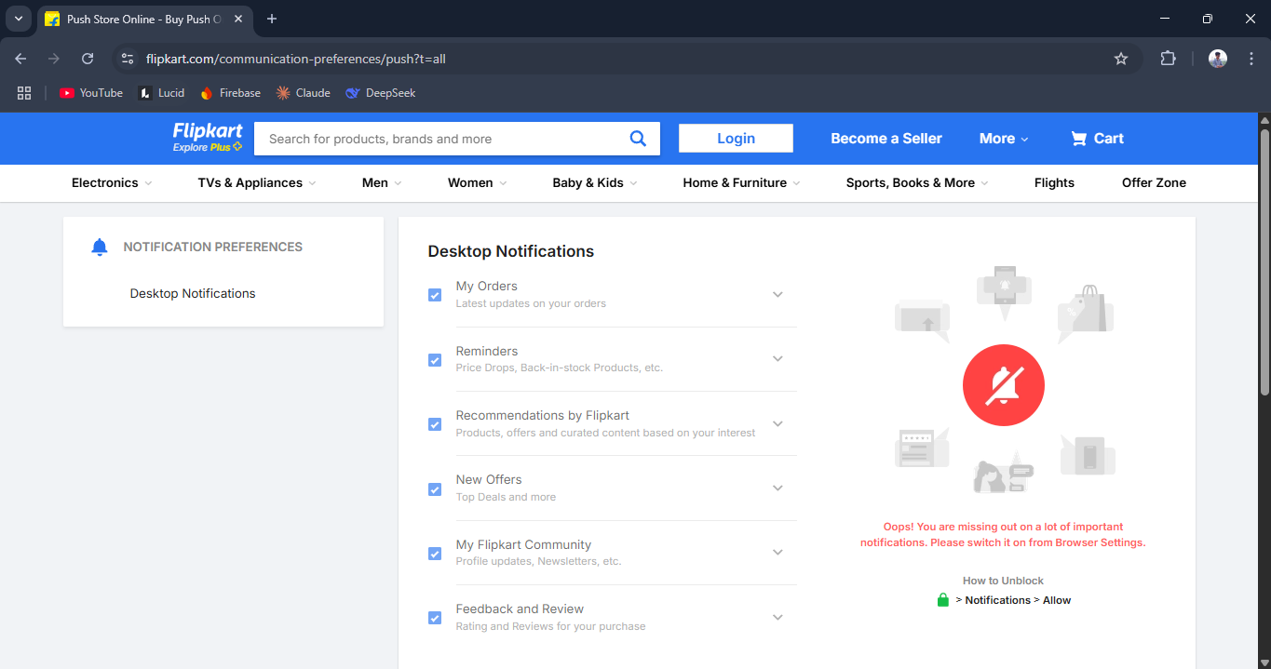

* Poor user personalization and no shared comparison support.
* **Example:** *Amazon.in* – Offers rich product data, but **lacks a comparison history, shareable link, or collaborative viewing** experience.

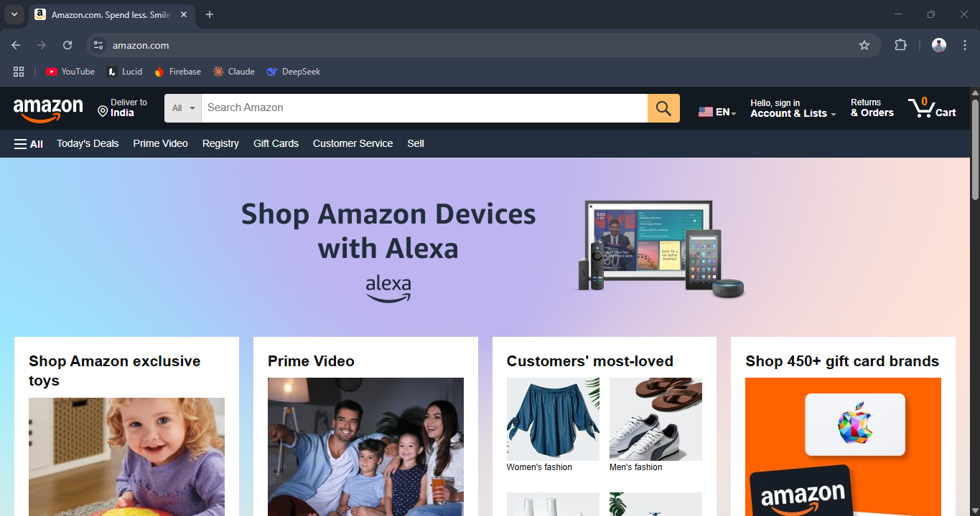

* Limited admin control – no discount control or custom curation.
* **Example:** *Snapdeal.com* – While sellers can apply discounts, there's **no centralized admin module** for scheduled, trackable discount campaigns.

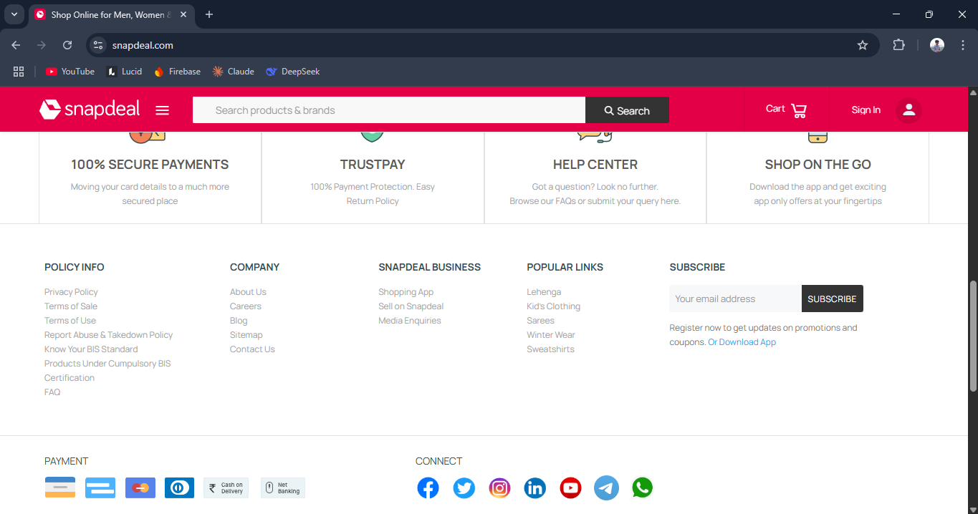

* Inadequate cart + checkout support (no multi-platform integration).
* **Example:** *Google Shopping* – Offers a multi-store view, but **redirects to external sites individually** for every product instead of a central cart experience.

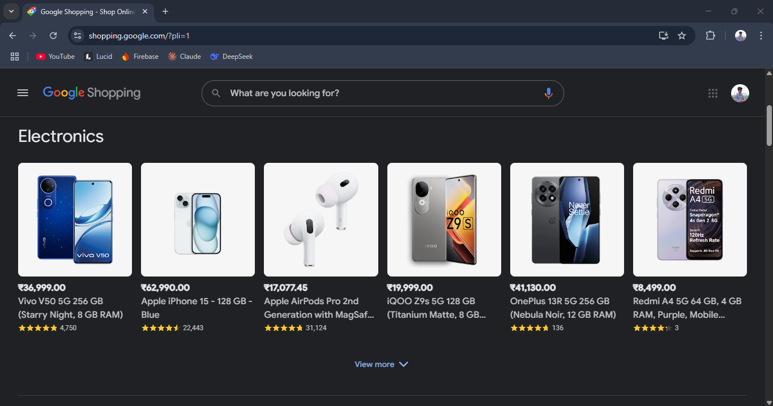

* Absence of order tracking and cancellation features.
* **Example:** *Gadgets360 (NDTV)* – While it provides mobile prices and specifications, it **does not support direct order placement, delivery tracking, or order cancellation**. Users are redirected to third-party sellers without any integrated post-purchase support.

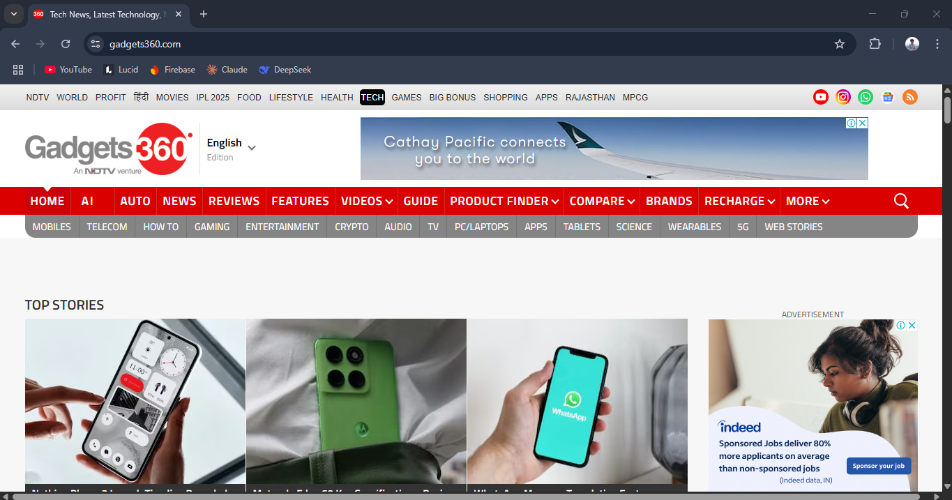

## Proposed Solution: EMWIS

To effectively address and overcome the limitations observed in existing mobile comparison and purchasing platforms, the **Economical MobiWise Insight System (EMWIS)** proposes a **unified, intelligent, and modular web-based ecosystem**. Rather than operating in silos like current platforms, EMWIS consolidates the functionalities of product discovery, real-time comparison, cart-based purchasing, price tracking, and order lifecycle management into a **single, user-centric platform**.

By combining **user experience innovation**, **intelligent data integration**, and **multi-role administrative control**, EMWIS introduces a set of **novel, thoughtfully engineered features**—both **creative (originated uniquely for this project)** and **general innovations (refined and tailored from existing concepts)**—to bridge the critical gaps between online research, local market options, and purchase decision-making. These innovations are not just enhancements but form a **comprehensive solution framework** that redefines how users interact with the mobile buying ecosystem.

## Innovative Features Introduced

**A. Creative Novelties (Author-Specific):**

1. **Shared Comparison Link Generation**  
   Users can generate a unique link of selected mobile comparisons to share across platforms.
2. **Discount Visualization + Admin-Defined Offers**  
   Admins define discount offers with timeline tracking, automatically restoring the original price after expiry.
3. **Real-Time WhatsApp Notifications**  
   When users order a discounted item or a price drop alert is triggered.
4. **Disqus-Enabled Comments with Auth Restriction**  
   Logged-in users can comment in a forum.
5. **Modular Admin Portal**  
   Role-based modules (Super Admin, Product Manager, Data Entry) with full CRUD operations.

**B. General Novelties:**

1. **AI-Powered Recommendation via Gemini**  
   After comparing mobiles, users get smart buying advice.
2. **Cart + Secure Checkout with Address Management**  
   Splits address data for structured logistics planning.
3. **Track and Cancel Orders**  
   Delivery stages updated dynamically, with cancellation logic and confirmation modals.
4. **JWT-Based Auto Login and Profile Header Replacement**  
   Retains login status with a profile icon replacing login button.
5. **Floating Chatbot with Conversation History**  
   Helps users resolve doubts instantly and resumes previous chats.

## Scope of the Project

* **Users:** Browse, compare, purchase, track, and manage mobile orders.
* **Admins:** Manage mobile inventory, discounts, and orders based on their roles.
* **Database:** Maintains structured records of users, mobiles, discounts, orders, and interactions.

## Project Architecture

* **Frontend:** HTML, CSS, JavaScript
* **Backend:** Python (Flask Framework)
* **Database:** Oracle Database (PyODBC)
* **API Integration:** WhatsApp (pywhatkit), JWT, Google Gemini, Disqus, Hugging Face

## Software Requirements

**Frontend:**

* HTML
* CSS
* JavaScript

**Backend:**

* Python
* Flask
* PyODBC

**Database:**

* Oracle 11g or higher

**Libraries and APIs:**

* JWT (authentication)
* pywhatkit (WhatsApp messaging)
* Google Gemini API (AI suggestions)
* Disqus API (commenting)
* Hugging Face (AI image generation)

## Implementation Timeline

|  |  |  |
| --- | --- | --- |
| Phase | Task | Duration |
| Phase 1 | Requirement Analysis & Planning | 1 week |
| Phase 2 | UI/UX Design | 3 weeks |
| Phase 3 | Backend Setup and DB Integration | 1 week |
| Phase 4 | Core Feature Implementation | 4 weeks |
| Phase 5 | Admin Module + Order System | 2 weeks |
| Phase 6 | Testing + Final Integration | 1 week |
| Phase 7 | Report, Video, and Deployment | 1 week |

## Expected Outcomes

* A reliable, fully functional mobile comparison and purchasing system
* Empowered admins managing dynamic offers and products
* Happy users benefiting from price drops, offers, and smooth tracking

## Conclusion

The **Economical MobiWise Insight System (EMWIS)** offers a powerful, scalable, and cost-effective solution to the fragmented mobile shopping experience currently available. By incorporating intelligent design, localized integration, and admin-driven controls, EMWIS positions itself as a next-generation platform built on innovation, utility, and user experience.

## References

1. [91mobiles](https://91mobiles.com/)
2. [Amazon](https://www.amazon.com/)
3. [Flipkart](https://www.flipkart.com/)
4. [Google Shopping](https://shopping.google.com/)
5. [Snapdeal](https://snapdeal.com/)
6. [Gadgets 360](https://www.gadgets360.com/)
7. [Javatpoint - Flask Tutorial](https://www.javatpoint.com/flask)
8. [W3Schools - HTML/CSS](https://www.w3schools.com/)
9. [Oracle Official Documentation](https://docs.oracle.com/)
10. [ChatGPT](https://chat.openai.com/)
11. [Google Gemini API](https://ai.google.dev/)
12. [Disqus Documentation](https://disqus.com/)
13. [pywhatkit GitHub](https://github.com/Ankit404butfound/pywhatkit)
14. [Flask Documentation](https://flask.palletsprojects.com/)
15. [Coolors Color Palette](https://coolors.co/)
16. [Hugging Face](https://huggingface.co/)